Updating Tax Tables Checklist
The tax tables need to be updated in Payroll BEFORE your January payroll. Download the two tax tables and then complete the following:
_____ From Payroll > Utilities > Install Salary/Tax Tables. Select Fed. Income Tax, type 2023 in the Calendar Year.
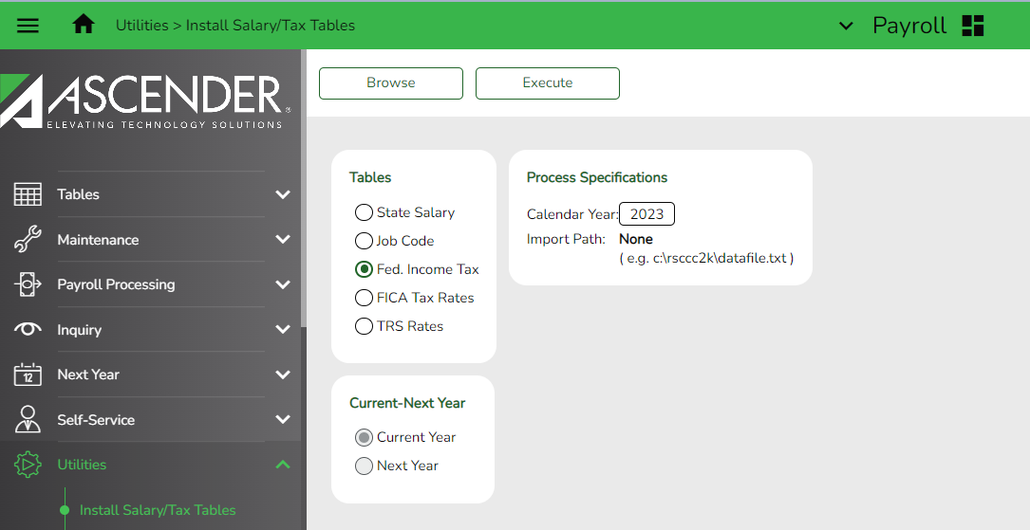
Browse to the 2023_Fed_Income_Tax.txt file on your computer. Click Submit, then click Execute.
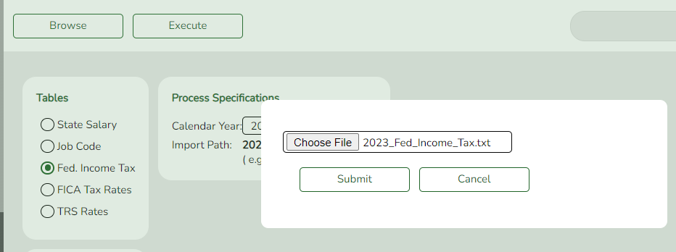

At the preview, select Process.

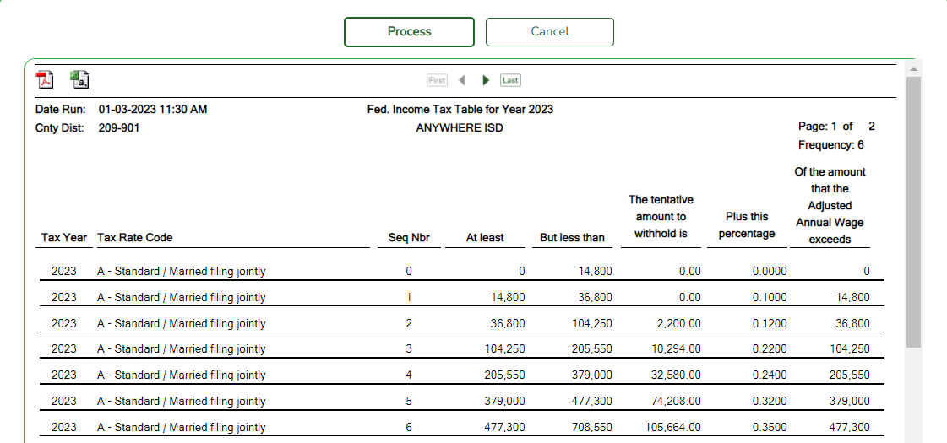
_____ Repeat the same process for the FICA tax file.
Select the radio button for FICA Tax Rates.
Browse: Select the radio button FICA Tax Rates and the file named 2023_FICA_Tax_Rates.txt. Submit, then select Execute.
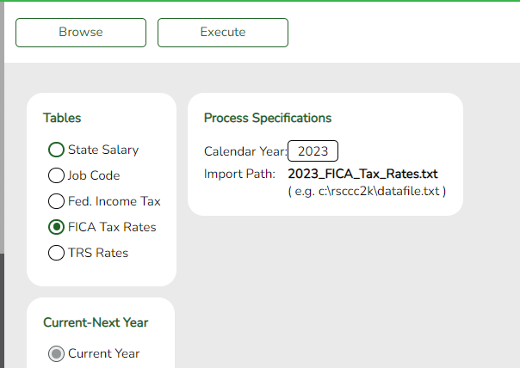

Select Process at the Preview.
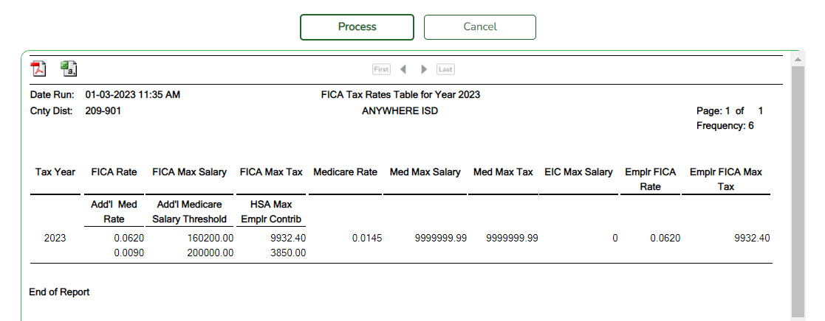

Resources: https://www.irs.gov/publications/p15t.

